PHASE 2 DOCUMENTATION

Step 1: Account creation and login

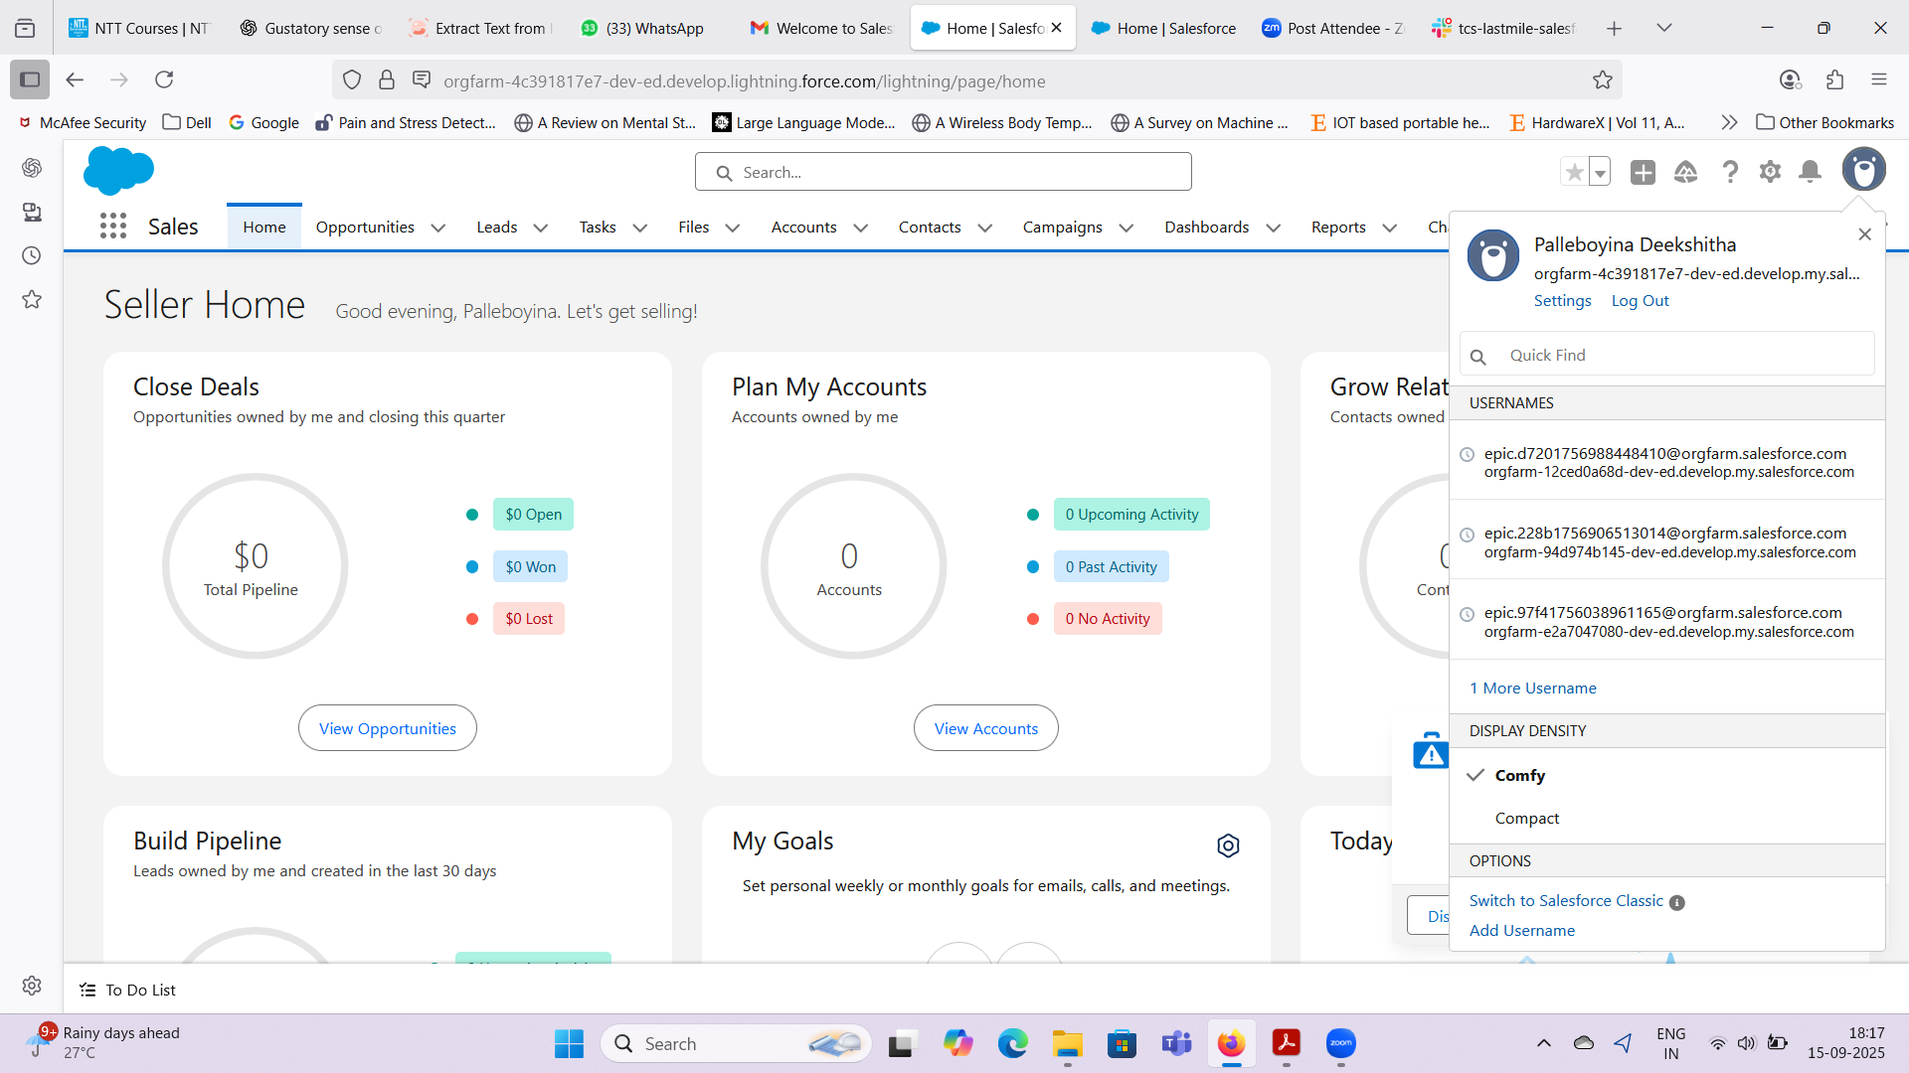

Step 2: App creation

* App Name: TalentBridge

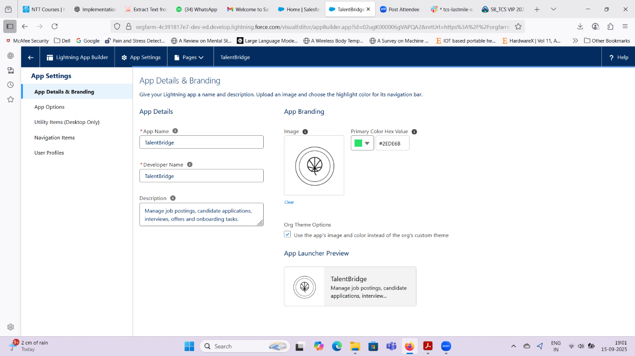

Step 3: Custom Object creation

* Created a custom object Job_c

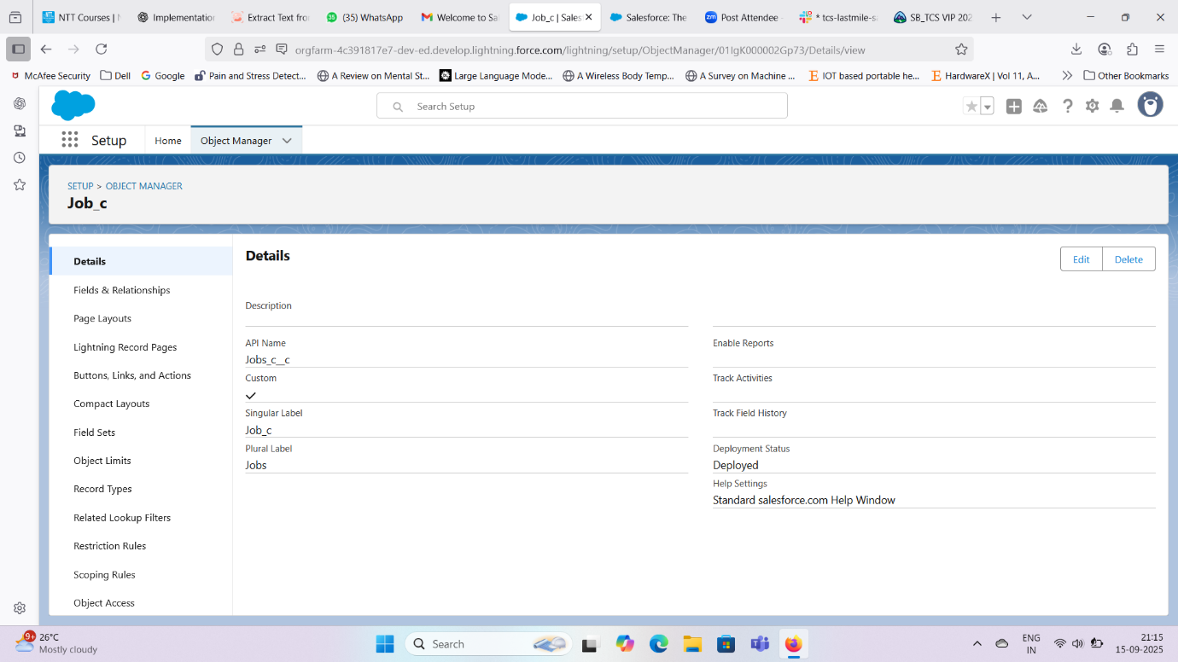

Step 4: Custom Field creation

* Created multiple fields and relations under Job_c relavent to the project.

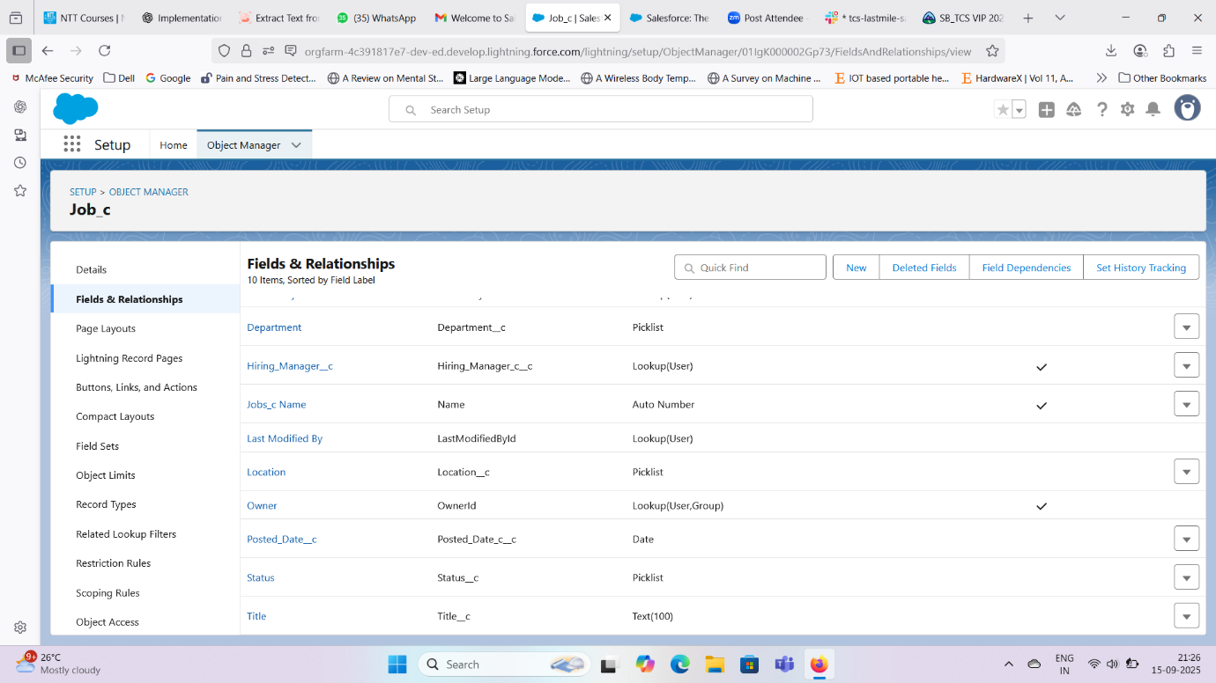

Step 5: Custom Tab creation

* Created a custom object tab for Job_c

